Algorithms Used

1.RNN

**Recurrent Neural Network(RNN)** are a type of [Neural Network](https://www.geeksforgeeks.org/tag/neural-network/) where the **output from previous step are fed as input to the current step**. In traditional neural networks, all the inputs and outputs are independent of each other, but in cases like when it is required to predict the next word of a sentence, the previous words are required and hence there is a need to remember the previous words. Thus RNN came into existence, which solved this issue with the help of a Hidden Layer. The main and most important feature of RNN is **Hidden state**, which remembers some information about a sequence.

RNN have a **“memory”** which remembers all information about what has been calculated. It uses the same parameters for each input as it performs the same task on all the inputs or hidden layers to produce the output. This reduces the complexity of parameters, unlike other neural networks

2. Feedforward Neural Network

**Deep feedforward networks**, also often called **feedforward neural networks**, or **multilayer perceptrons**(MLPs), are the quintessential deep learning models. The goal of a feedforward network is to approximate some function f*. For example, for a classiﬁer, y = f*(**x**) maps an input **x** to a category **y**. A feedforward network deﬁnes a mapping **y**= f(**x**;**θ**) and learns the value of the parameters **θ**that result in the best function approximation.

3. LSTM Neural Network

Long Short-Term Memory (LSTM) networks are a type of recurrent neural network capable of learning order dependence in sequence prediction problems. This is a behavior required in complex problem domains like machine translation, speech recognition, and more. LSTMs are a complex area of deep learning. It can be hard to get your hands around what LSTMs are, and how terms like bidirectional and sequence-to-sequence relate to the field. In this post, you will get insight into LSTMs using the words of research scientists that developed the methods and applied them to new and important problems. There are few that are better at clearly and precisely articulating both the promise of LSTMs and how they work than the experts that developed them.

Design and development Architecture

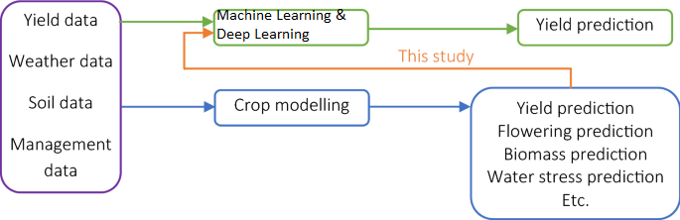

Using Python we are implementing our project

Using TKINTER